Map
- Symposium sessions will be held in the conference center at the National Center for Weather and Climate Prediction (NCWCP)
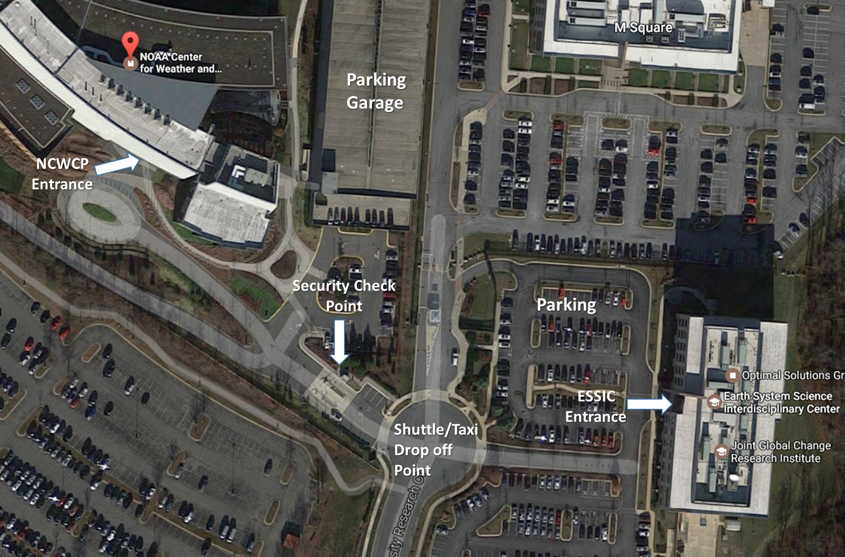
- The poster session on May 31st will be held at the University of Maryland’s Earth System Science Interdisciplinary Center (ESSIC)

Directions to NCWCP – Shuttle/Taxi/Metro/Bus
- Those arriving by shuttle or taxi will be dropped off in the circle between NCWCP and ESSIC.

- Proceed to the security check point. At the security check point you will be required to show a government ID (e.g. passport). Let the guard know that you are here to attend the symposium.

- If you arrived my metro, you can walk to the entrance point or take the UMD shuttle to NCWCP.

You may view a detailed shuttle schedule here: http://www.transportation.umd.edu/images/Shuttle/Schedules%20pdfs/upComing/109_RR.pdf

College Park Metro Info: http://wmata.com/rail/station_detail.cfm?station_id=79

Bus, Train and Metro Schedules/Information: http://mta.maryland.gov/

- After passing through the security check point, proceed to the main entrance. When you enter the facility, take an immediate right through the double doors to enter the conference center. You do not need to check in at the security desk. Registration will be inside the double doors in the conference center.
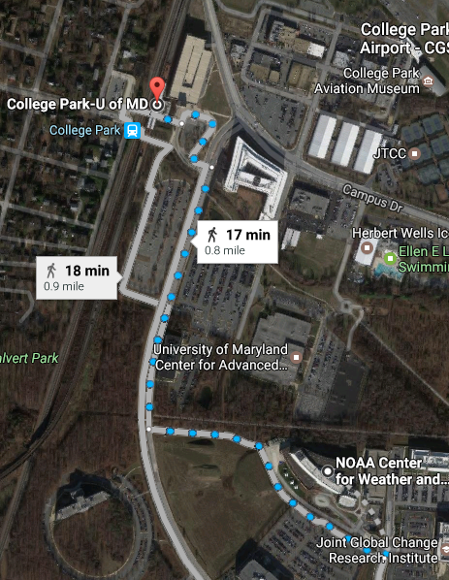
Directions NCWCP – Driving
- From Maryland:

  - Take I-495 East to exit 23A (Kenilworth Ave/MD-201 S). Stay on 201 S and make a right onto River Rd. Take the 1st right onto University Research Court. The NCWCP building is at the end of the circle on the left side.

- From Virginia:

  - Merge onto I-495 OUTERLOOP/Capital Beltway/ toward Alexandria. Take the I-295 N/National Harbor exit, EXIT 2A-B, toward Washington. Keep right to take DC-295 N toward US-50 E (crossing into Maryland stay in Middle lane) to 201 North Kenilworth Ave). Turn left onto River Rd. Take the 1st right onto University Research Court. The NCWCP building is at the end of the circle on the left side.

- From Washington, DC:

  - Take I-295 North (Middle lane) to 201 North Kenilworth Ave. (Cross East-West Hwy/MD-410) left onto River Rd. Take the 1st right onto University Research Court. The NCWCP building is at the end of the circle on the left side.
- Parking:

  - Visitors can park in the NCWCP parking garage or in the ESSIC parking lot.

  - To get through the Security Check Point at NCWCP by car, pull up to the gate on the right. Let the guard know that you are here to attend the symposium. You will be required to show a government ID (e.g. passport) at the check point.

  - After passing through the security check point, proceed to the main entrance. When you enter the facility, take an immediate right through the double doors to enter the conference center. You do not need to check in at the security desk. Registration will be inside the double doors in the conference center.

